

Page d’Authentification
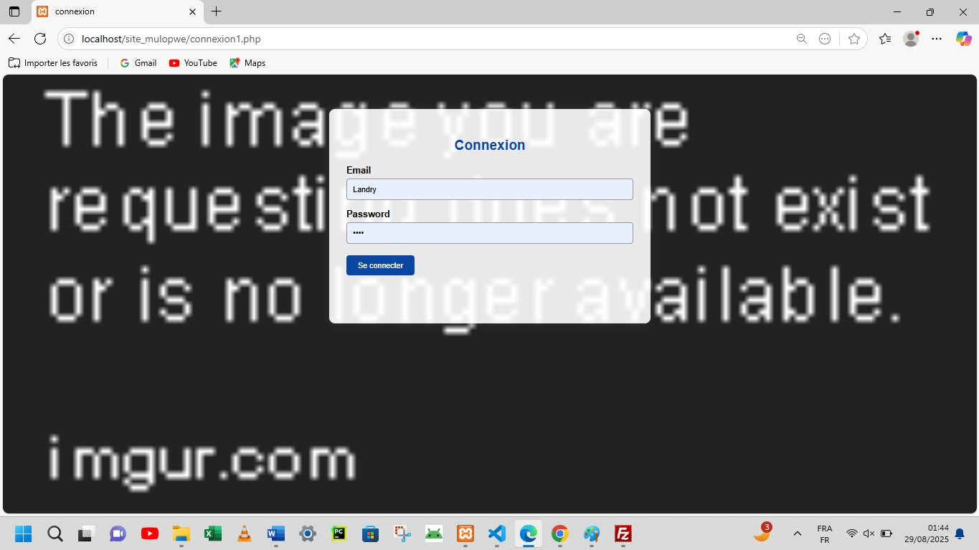

Formulaire d’Envoi de Rapport
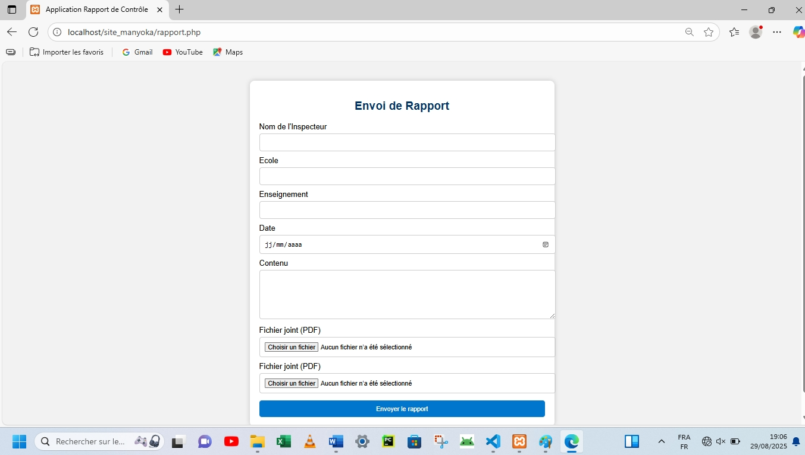

CODE
<!DOCTYPE html>
<html lang="fr">
<head>
<meta charset="UTF-8">
<title>Application Rapport de Contrôle</title>
<style>
body {
font-family: Arial, sans-serif;
margin: 0; padding: 0;
background: #f2f2f2;
}
.section {
max-width: 600px;
margin: 40px auto;
padding: 20px;
background: white;
border-radius: 10px;
box-shadow: 0 0 10px rgba(0,0,0,0.2);
}
h2 {
text-align: center;
color: #003366;
}
label {
display: block;
margin-top: 10px;
}
input, textarea, select {
width: 100%;
padding: 10px;
margin-top: 5px;
border: 1px solid #ccc;
border-radius: 5px;
}
button {
margin-top: 15px;
width: 100%;
padding: 10px;
background: #0077cc;
color: white;
border: none;
border-radius: 5px;
}
table {
width: 100%;
border-collapse: collapse;
margin-top: 10px;
}
table, th, td {
border: 1px solid #aaa;
}
th, td {
padding: 8px;
text-align: left;
}
</style>
</head>
<body>

<!-- 2. Formulaire d'envoi de rapport -->
<div class="section">
<h2>Envoi de Rapport</h2>
<form action="traiterrapport.php" method="post" enctype="multipart/form-data">
<label>Nom de l'Inspecteur</label>
<input type="text" name="nom"required>
<label>Ecole</label>
<input type="text"name="titre" required>
<label>Enseignement</label>
<input type="text"name="titre" required>
<label>Date</label>
<input type="date" name="dateenv"required>
<label>Contenu</label>
<textarea rows="5" name="contenu" required></textarea>
<label>Fichier joint (PDF)</label>
<input type="file" accept=".pdf" name="fichier1">
<label>Fichier joint (PDF)</label>
<input type="file" accept=".pdf" name="fichier2">
<button type="submit">Envoyer le rapport</button>
</form>
</div>

</body>
</html

